Grace & Elegance Boutique

PAGE TEMPLATE DESIGN

Introduction
Grace And Elegance Boutique website will have a clean, modern, and user-friendly page template design. This is to make the website visually pleasing and easy to navigate through. A sign up tab will pop up when a user opens the website. This is designed to see repeat customers, faster check out and show exclusive deals to the user.
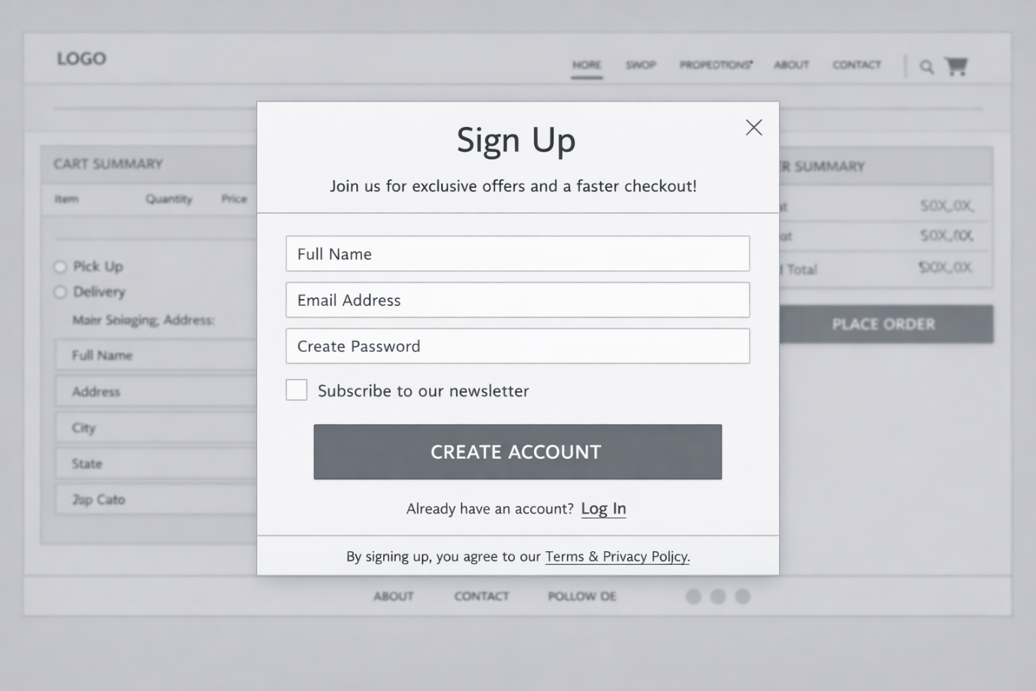

Home Page
The Home Page will include a header with the company logo and navigation menu. The navigation menus will be Home, Shop, About Us, Contact, Promotions and Cart. Below there will be a hero section with high quality images and a promotional tagline. A short welcome message will be below the hero section. Then a featured products section will be made along with a call to action button. A footer will be included at the bottom containing contact details, important links and terms and conditions of the Boutique.
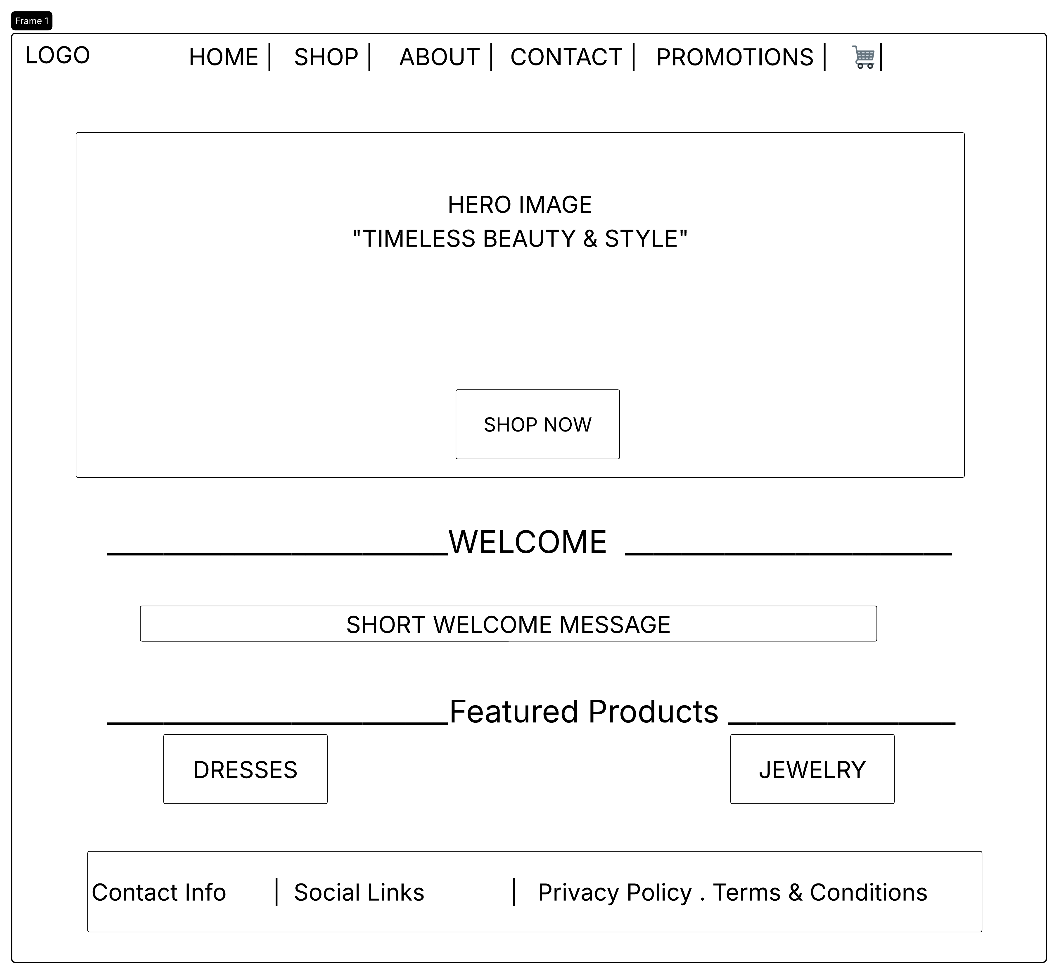

SHOP PAGE
Products will be displayed using Shop tab in the navigation bar. When a customer clicks on this tab, they will be taken to the Shop Landing Page, which is divided into three sections which are Women, Kids, and Jewelry. In the Women and Kids sections, customers can choose the type of dress they want, such as Formal, Casual or Party. In the Jewelry section, they can choose between Earrings, Necklaces, or Bracelets.

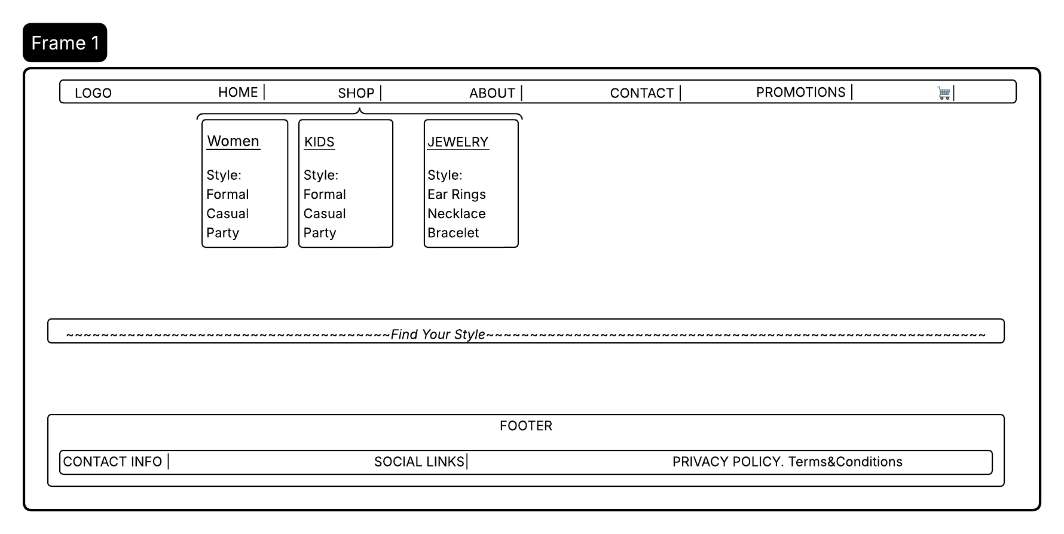

After selection of category and style, the user will be taken to the Product Listing Page. This page will show only the items they selected. On this page, products are displayed in a grid, and each product includes an image, name, price, and an “Add to Cart” button. A filter will be added on the left.

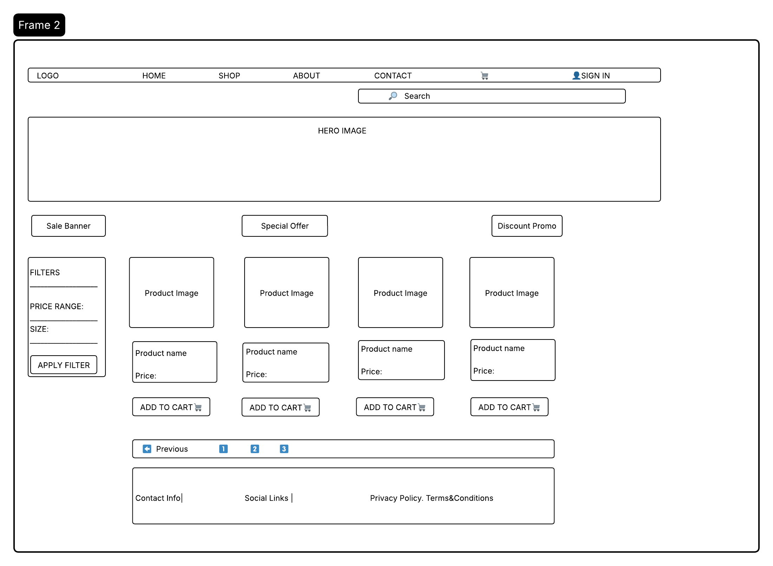

If a user desires to see more details about their product. They click on the image and it will take them to the Product Description Page. Here a user can get detailed information about the product selected. A quantity button will be added and a add to cart button.

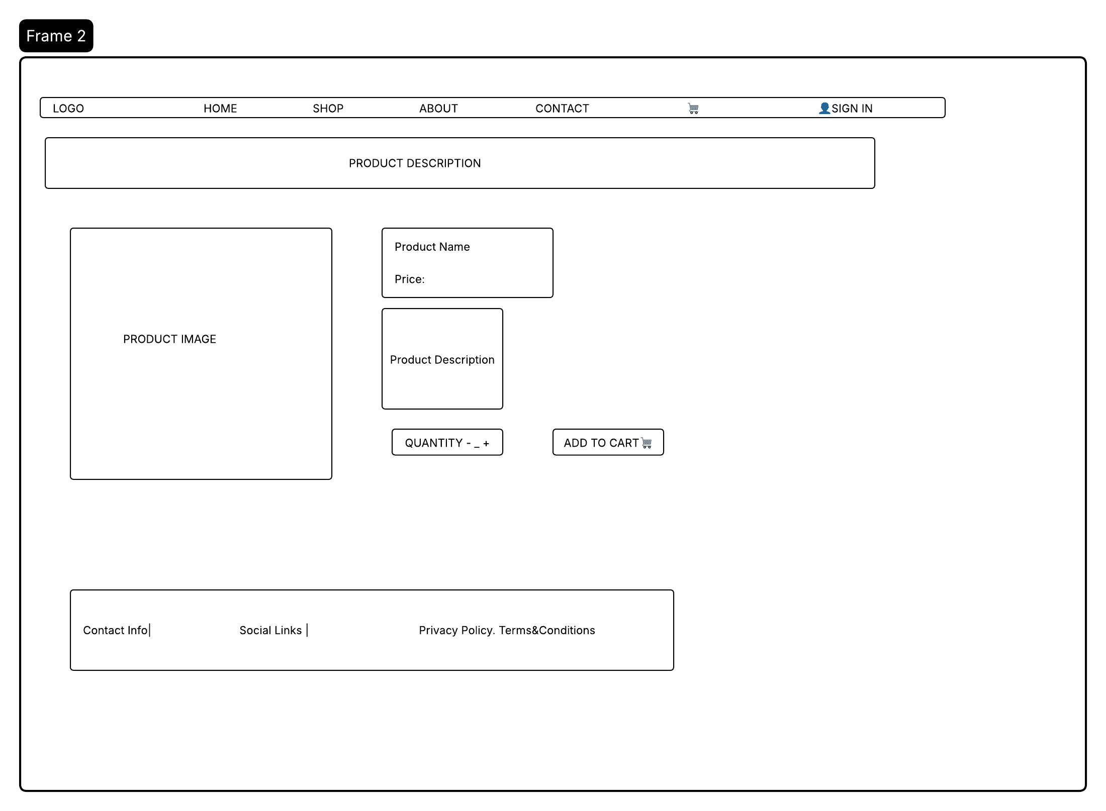

CUSTOMIZED DRESS PAGE

This section is for users who desire to place an order for a customized dress. The dress will be tailored according to a users preference. This includes measurements, style, type of fabric and design. To achieve this there will be two sections namely Visit Our Boutique(Recommended) and Design It Yourself.

The Visit Our Boutique section which is our recommended section allow a user to book an appointment to meet our designers where they will be professionally measured and get to consult with a designer. This ensures a customer is happy with their order, accurate measurements and allows detailed discussion about the dress.
The Design It Yourself allows a user to independently submit their dress specifications without the need to come to the Boutique. This is achieved through uploading images for dress inspiration, providing a written description of desired dress and input of measurements. It is ideal for customers who are confident in their measurements and a clear idea of what they want. Furthermore saving the user time from coming to the Boutique. A submit button will be added below. A note will be added at the end to emphasize our recommended section. A pop up message will show if order was placed successfully.

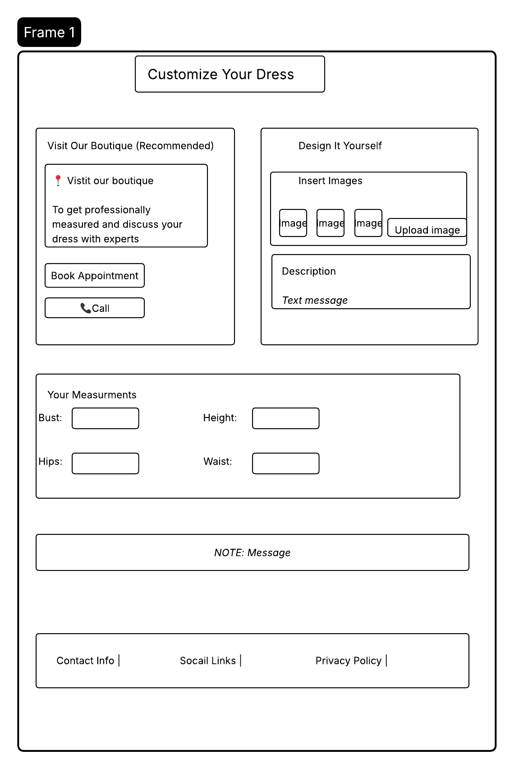

ABOUT US PAGE
The About Page will provide a user with the background, mission, and identity of the boutique.

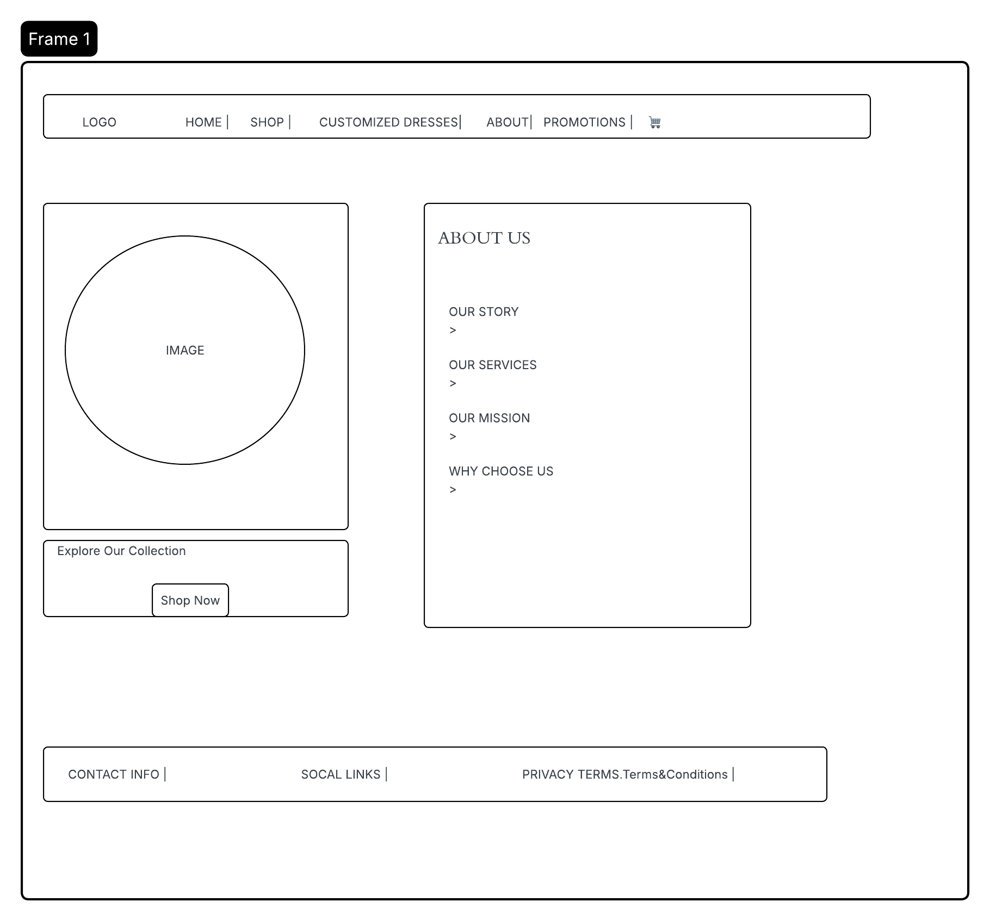

CONTACT US PAGE
The Contact Page will include a contact form, contact details and location of our boutique. This page is designed to help a user to contact us easily about any inquires.

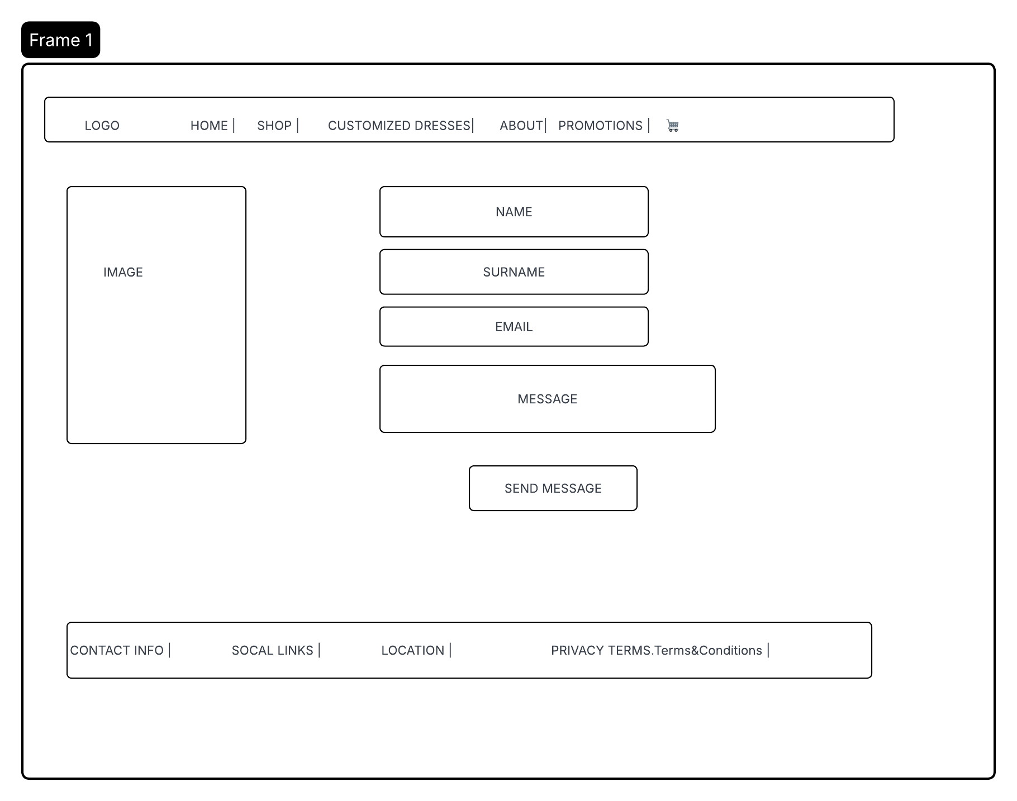

PROMOTION PAGE
The Promotions Page will highlight discounts, special offers, and limited-time deals to attract customers.

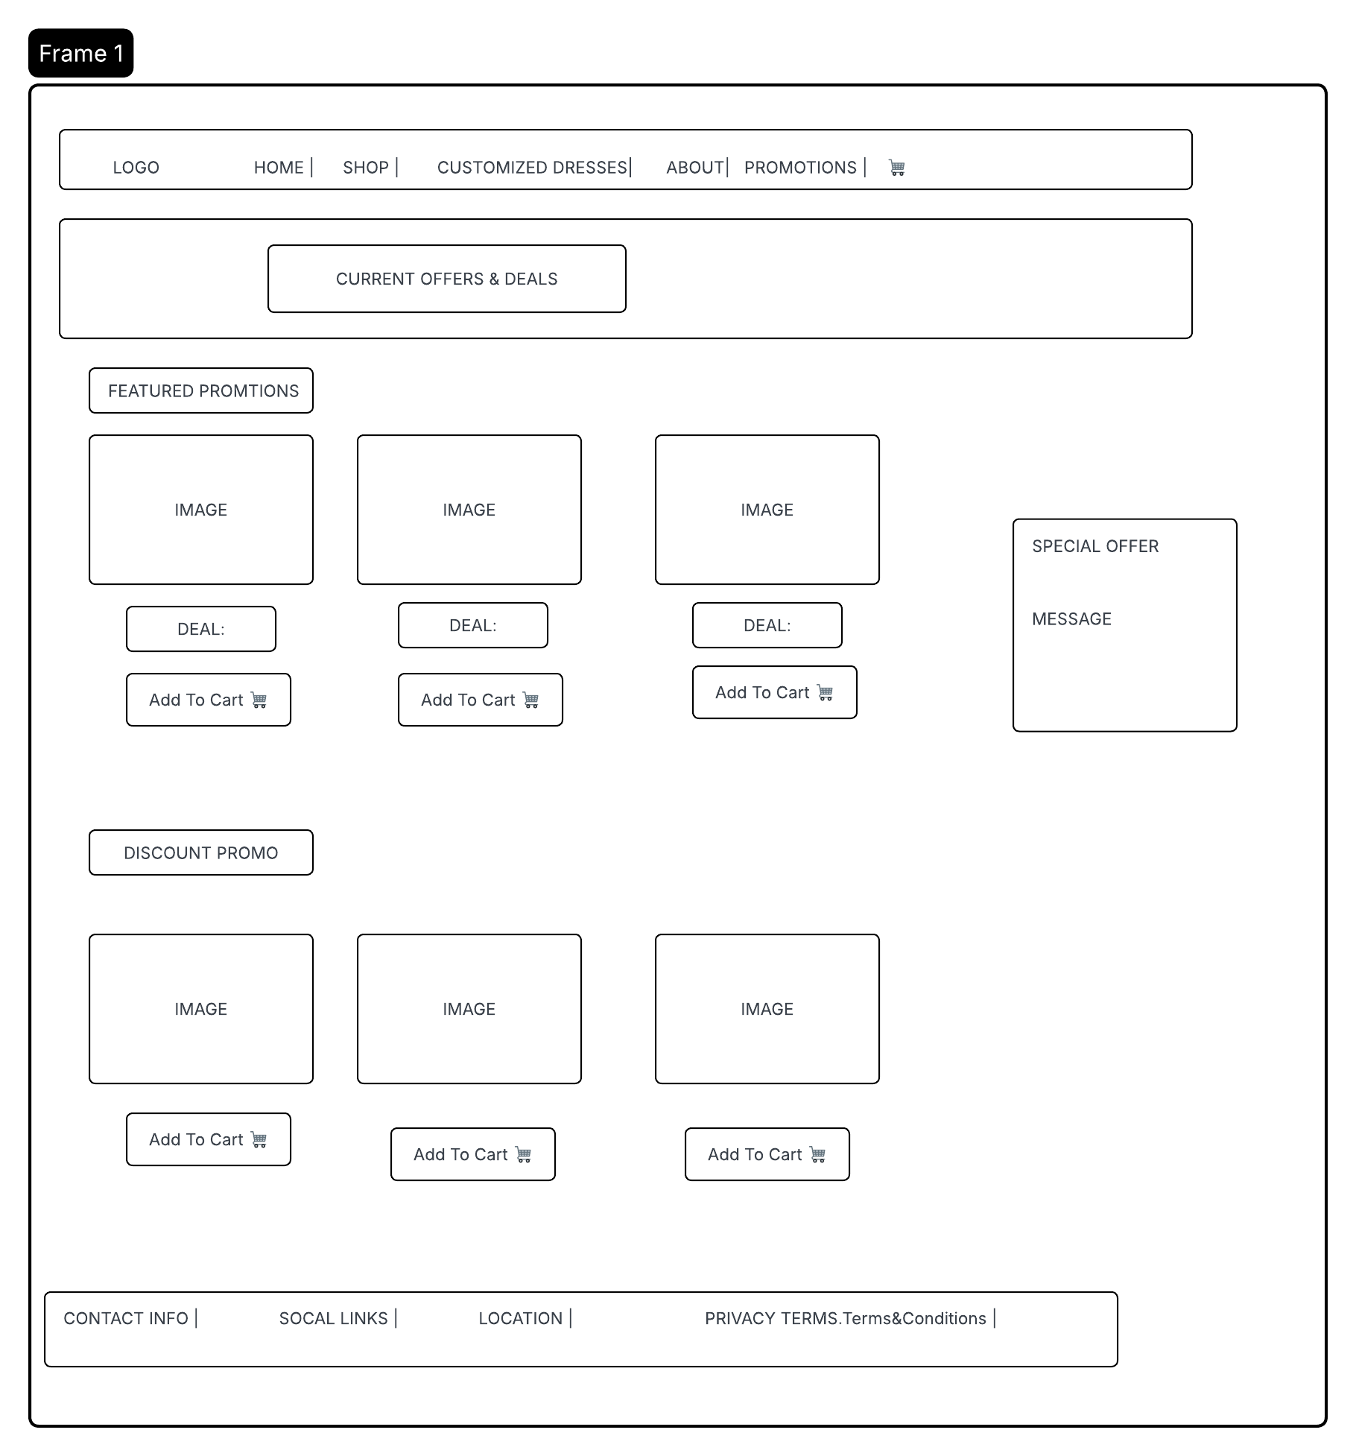

CART PAGE
The Cart Page will allow users to view selected items, update quantities, and proceed to checkout. A checkout button will be placed below. When the user is satisfied with their order they click it.

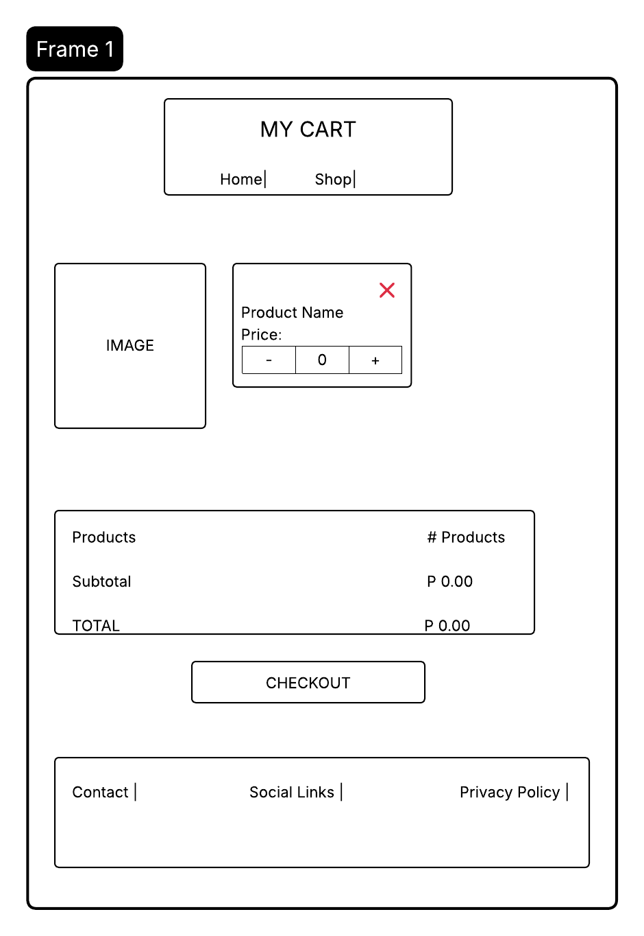

The check out button will direct them to a Check Out Page. Here a user selects if they want a delivery or they will pick up the order themselves. If a user selects Delivery, user will be prompted to input their address. Then user is required to select their method of payment ( visa card or PayPal). A form will pop up for a user to input their banking details.

A user then gets to see order summary, being Subtotal, Delivery Fee and TotalAmount. A user then clicks the Place Order button. And a verification message will pop if the order was successful. A receipt will be forwarded to a users email.
